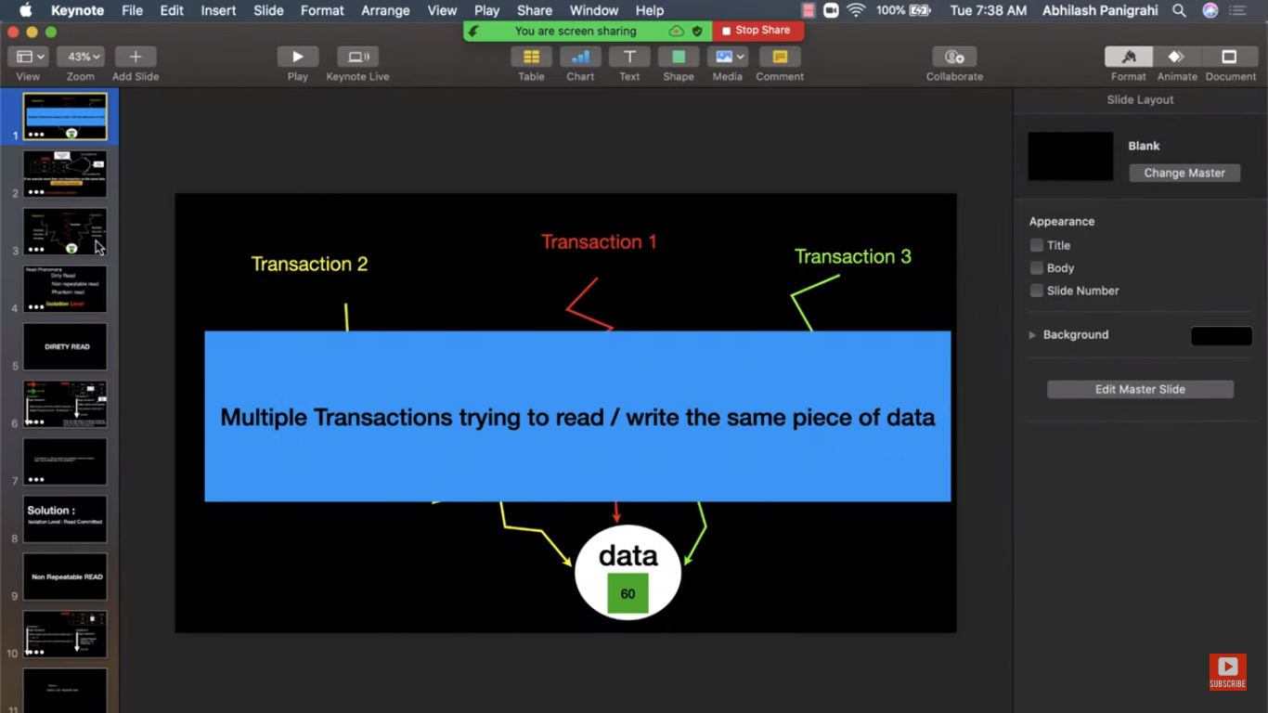

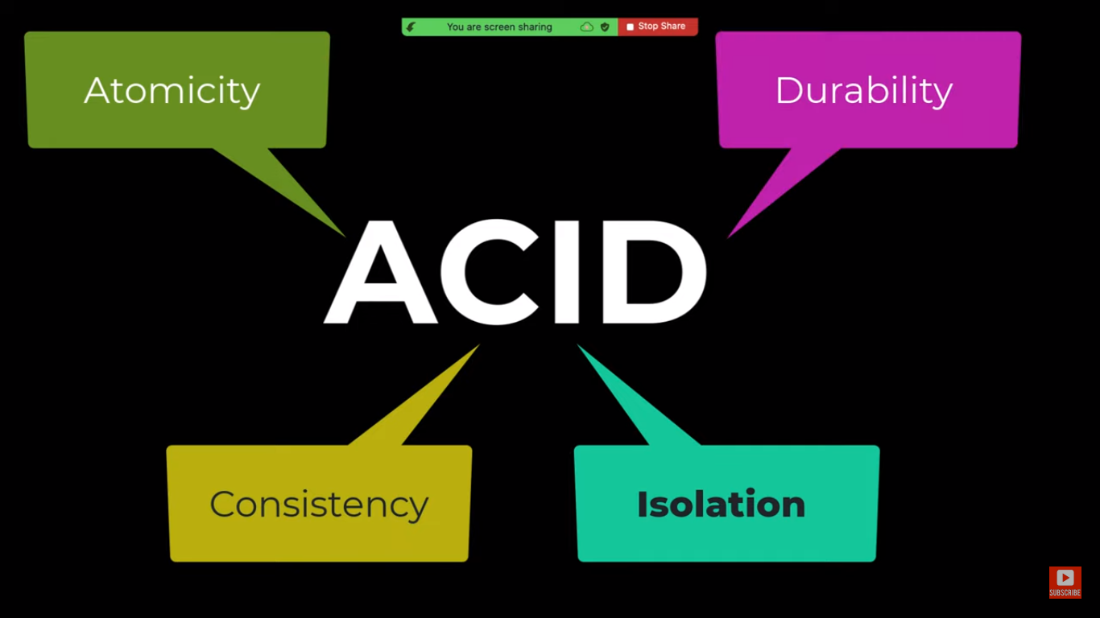

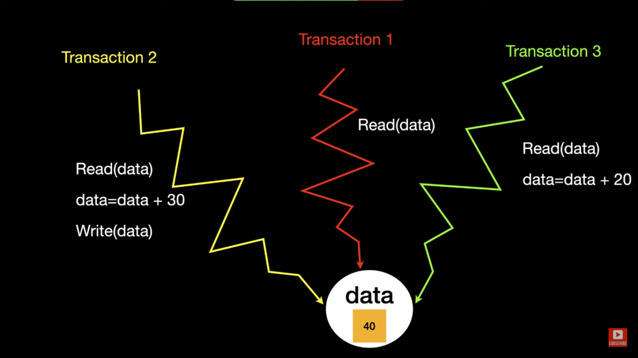

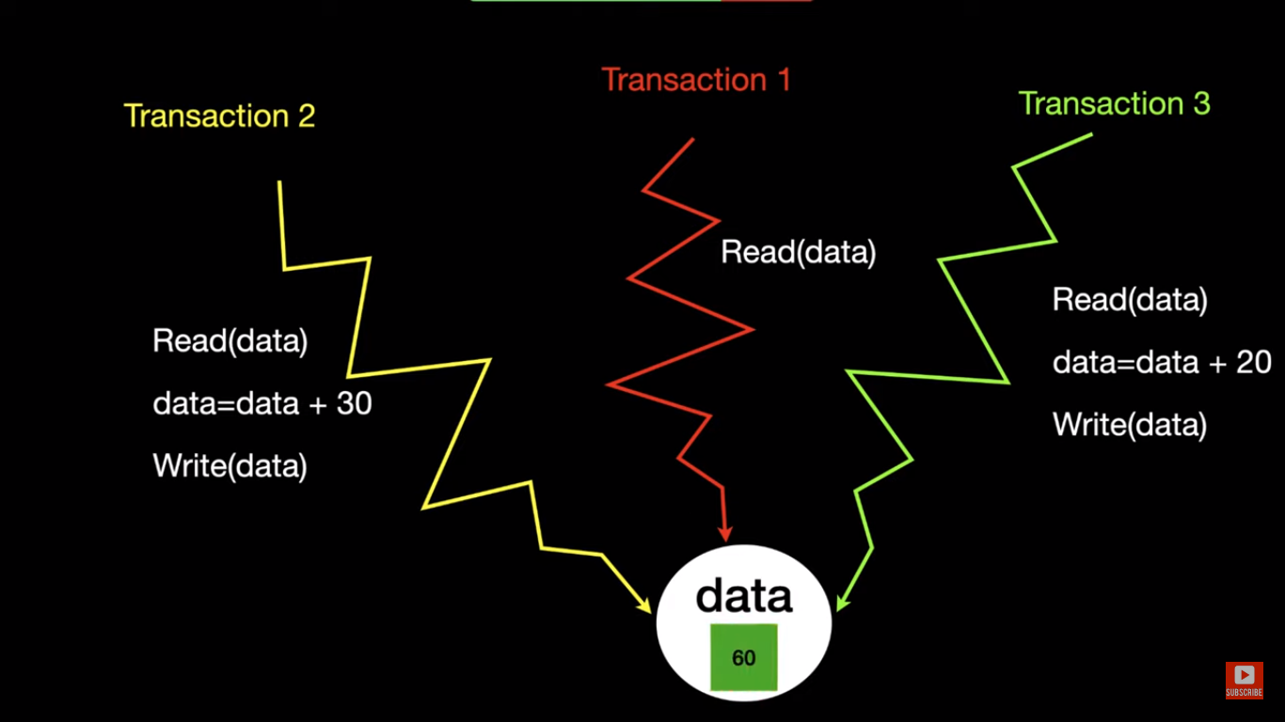

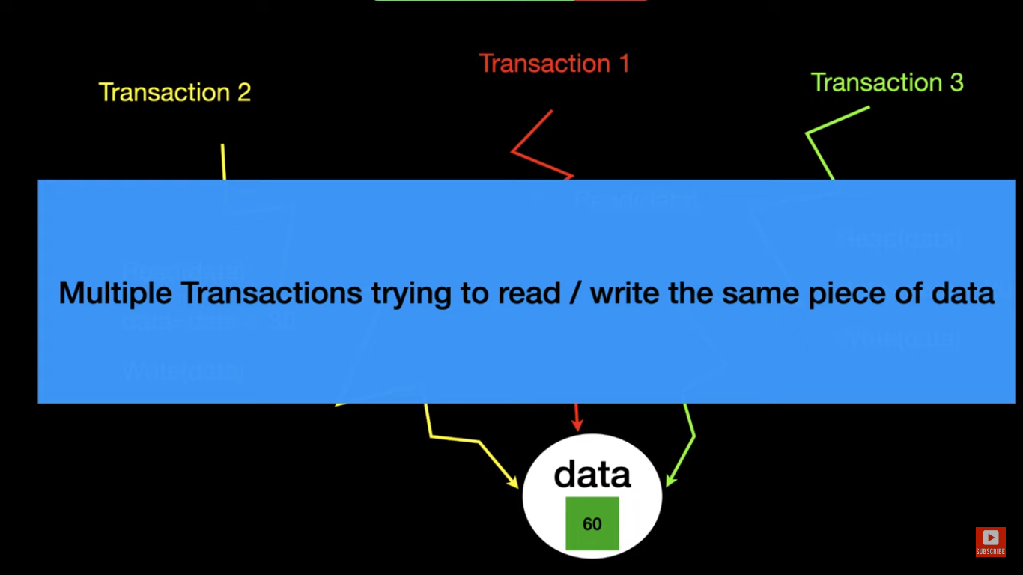

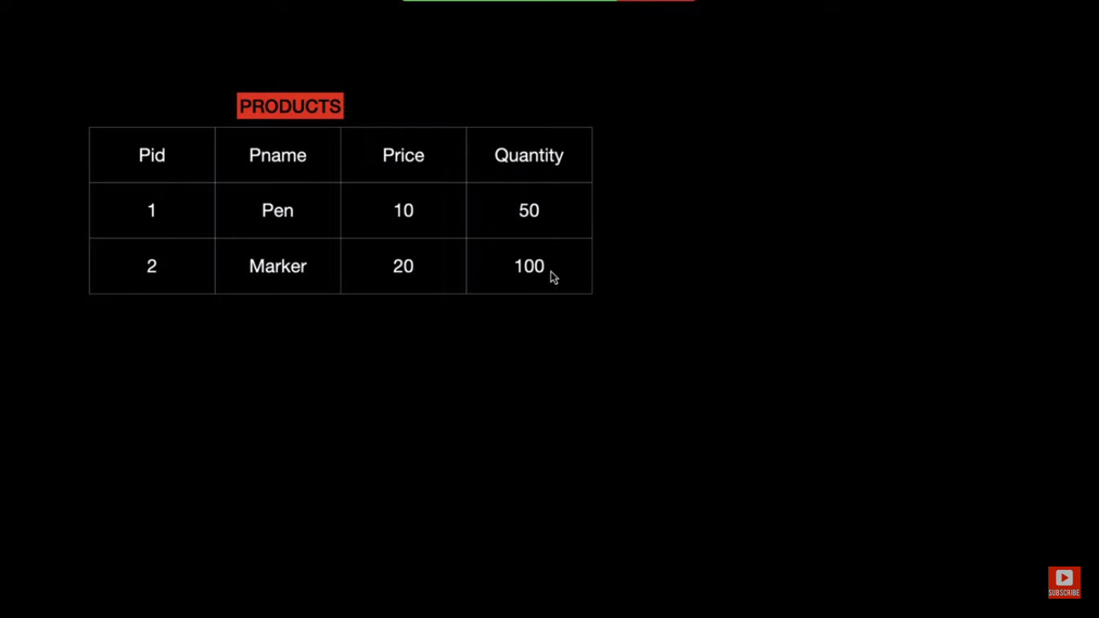

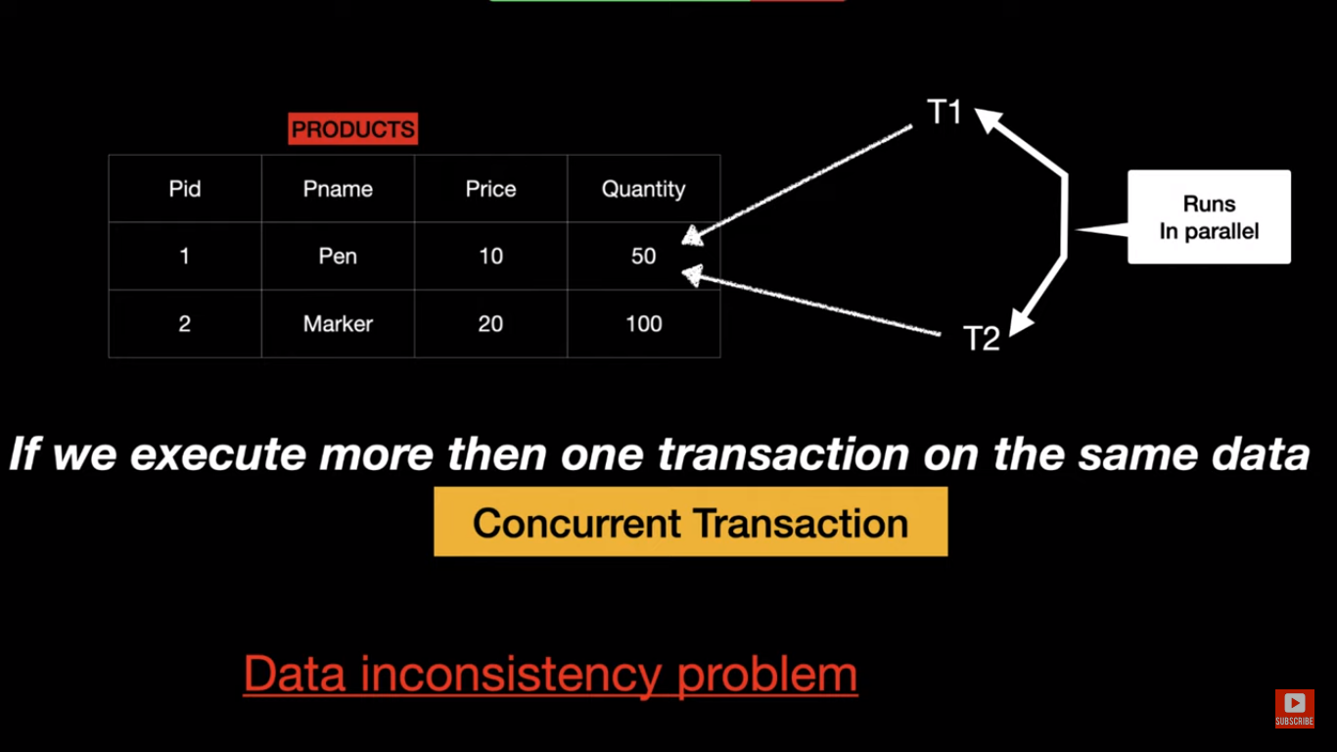

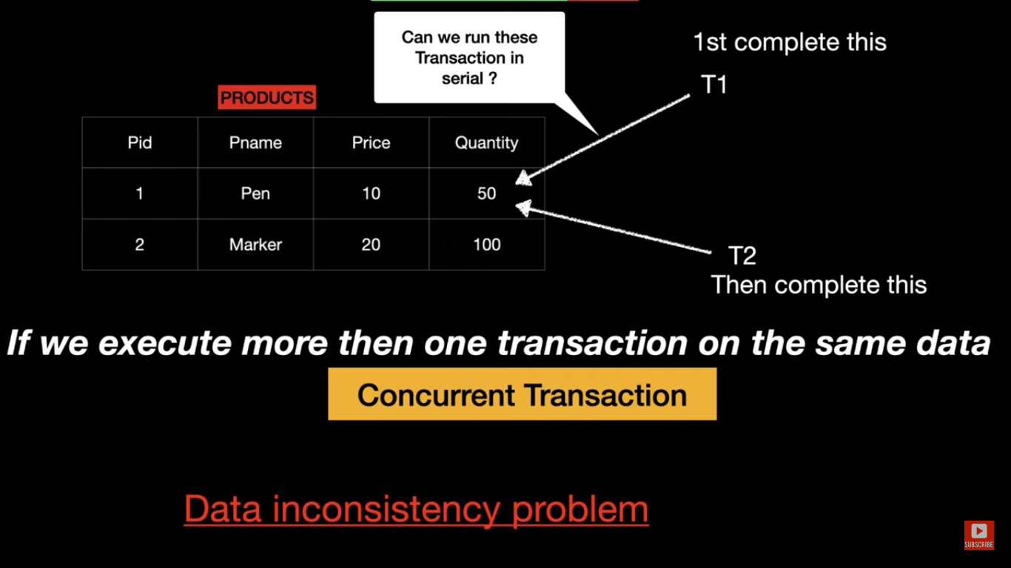

Let’s say there is a product table and there are two transactions running in parallel on same table data.T1 is increasing Quantity by 10.So will this change should be visible to T2 or not. This can be controlled using Isolation levels.

So when transactions are running in parallel so CPU time will be given to Transaction T1 for some time and other time T2 is running.

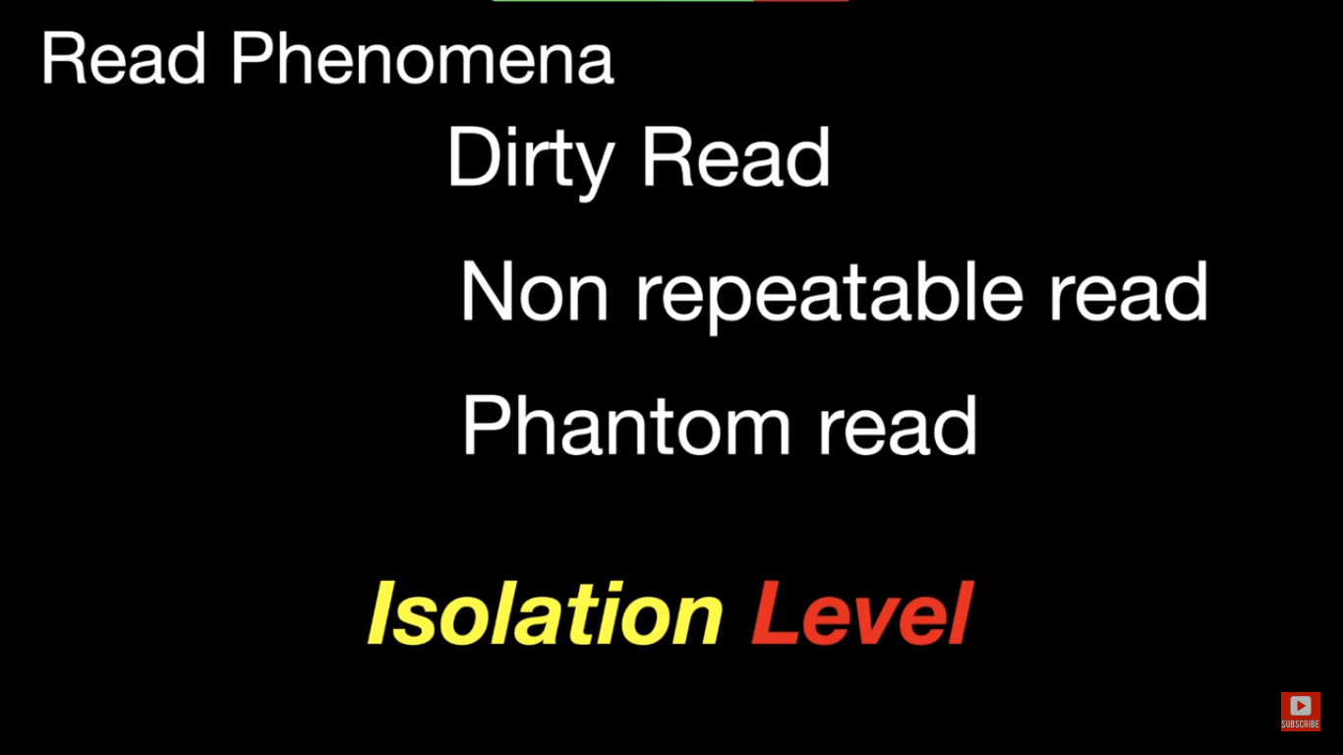

**REPEATBALE_READ ->**

Suppose there are two transactions T1 and T2 running in parallel.

T1 is started and T2 is started. T1 has updated the value of price from 10 to 50. But not committed.

In T2 , suppose we are firing select query to get the price then we get it as 10 .

We again went to T1 and committed the result of update query. Again switch back to T2.

Again we fire the select query . we will still get price as 10 only.

Because the ISOLATION LEVEL is REPEATBALE_READ . It means we will get repeated values for read in same transaction.

Once we close transaction t2 and again start it then it will fetch updated price 50.

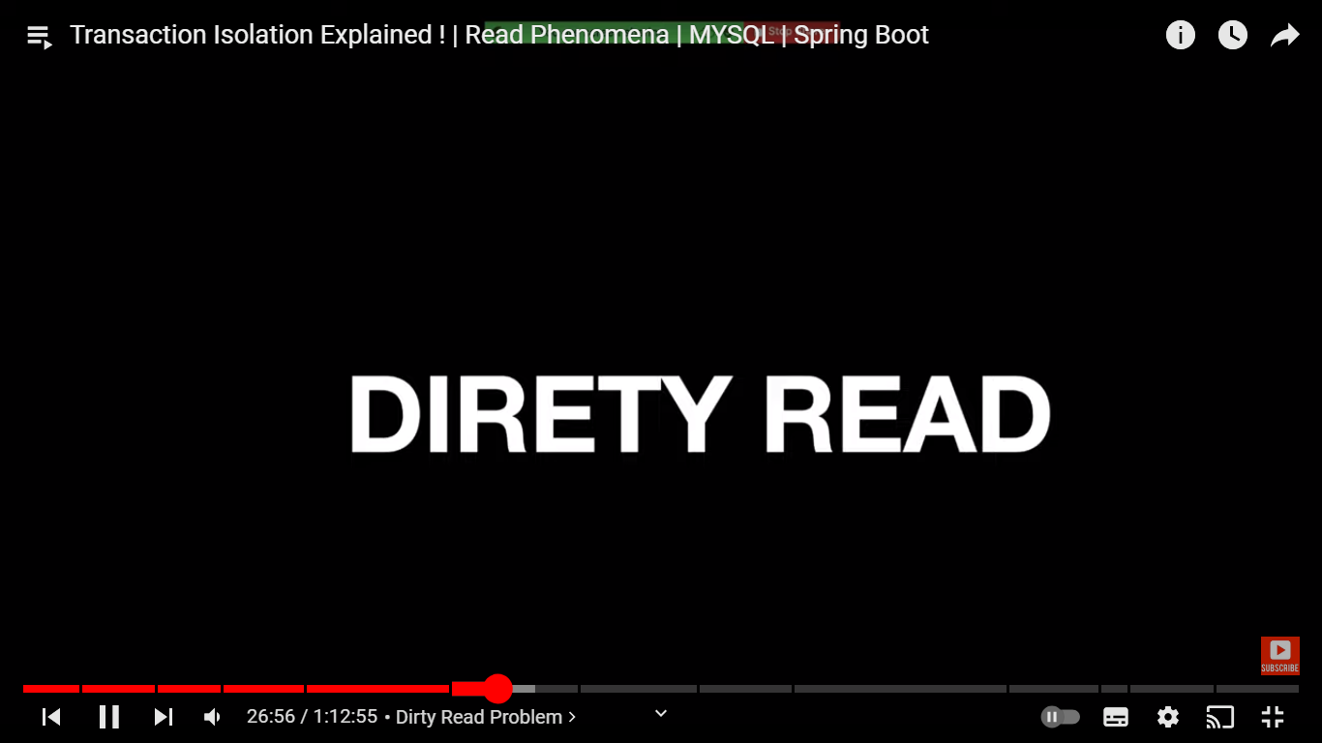

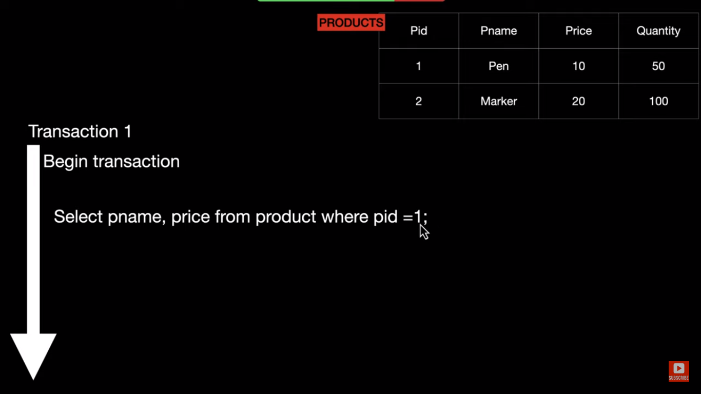

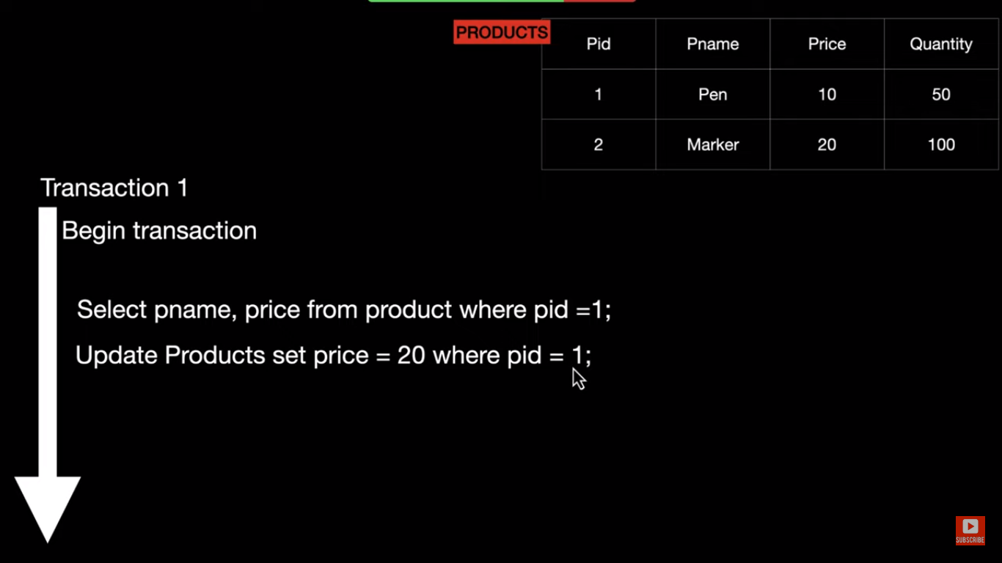

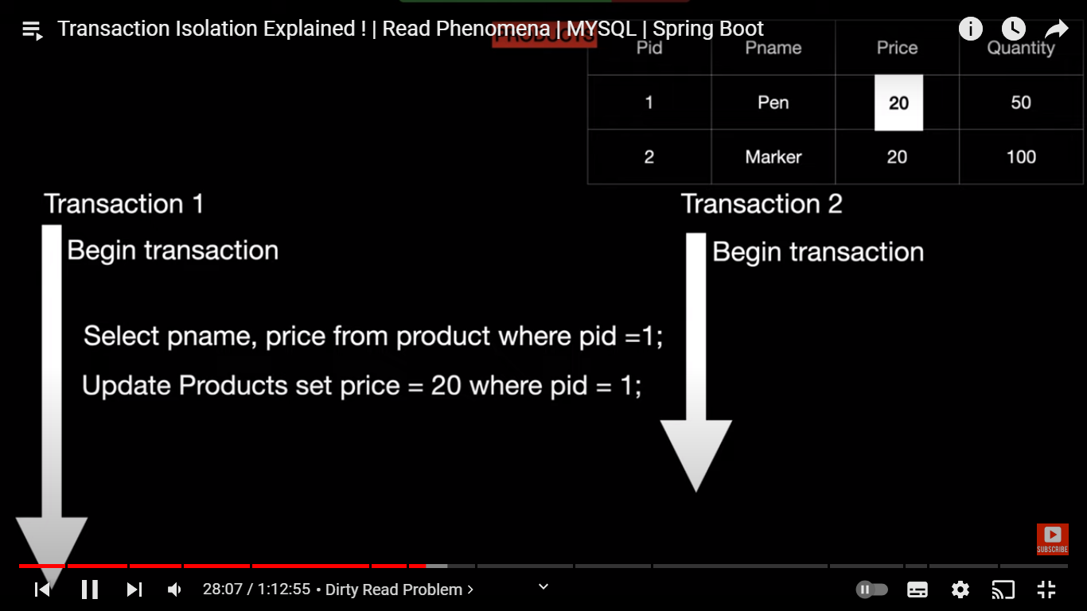

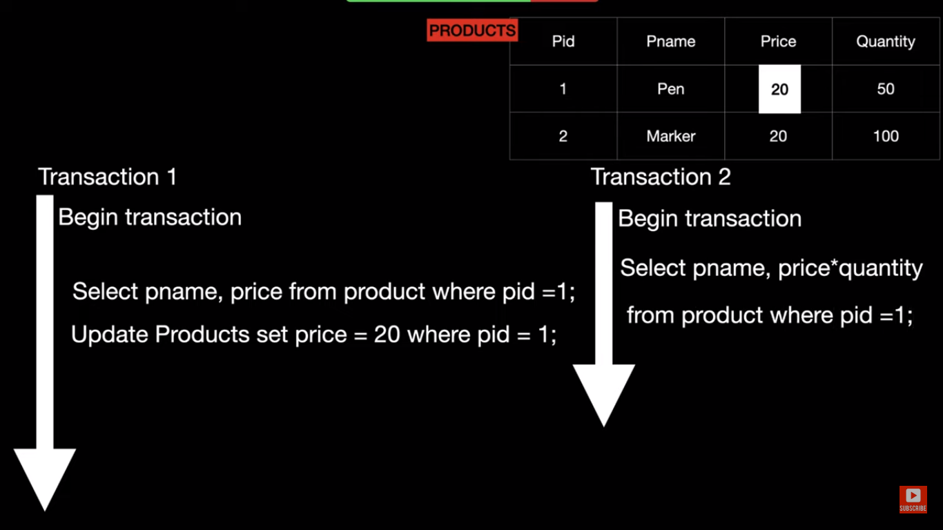

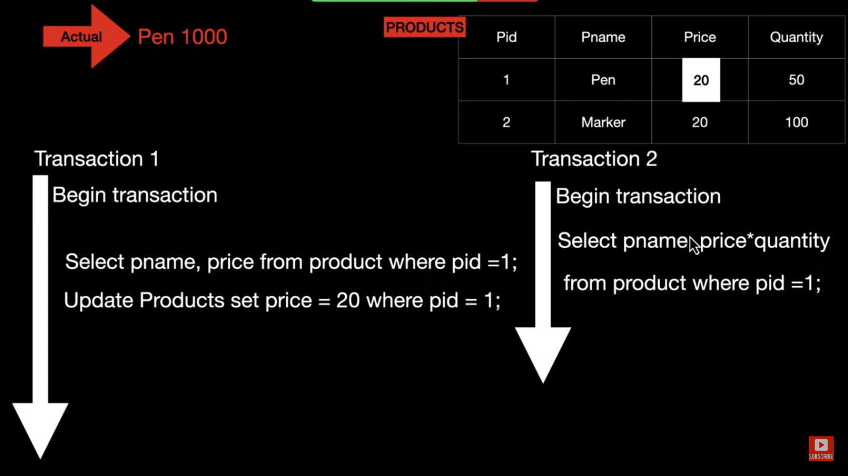

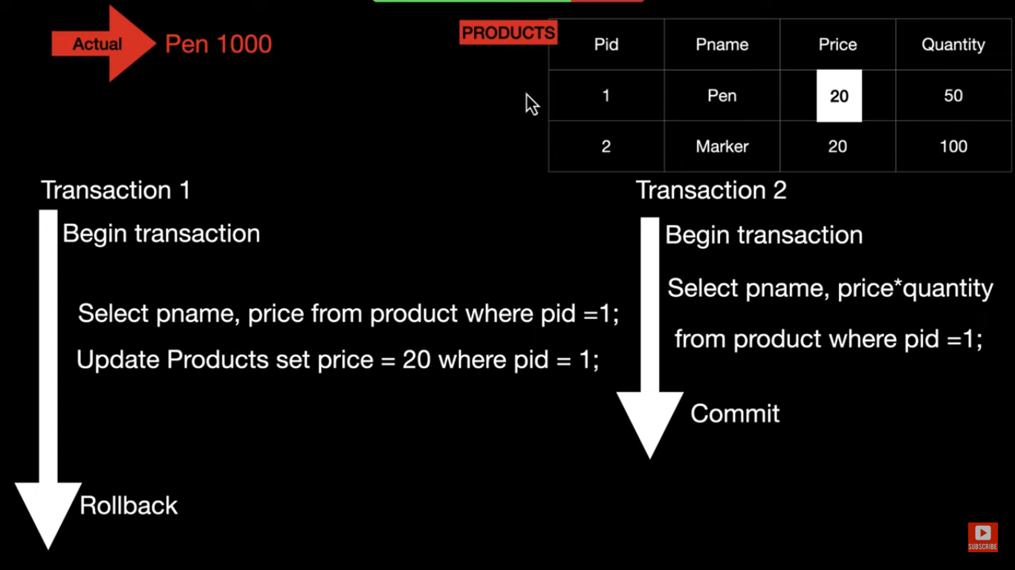

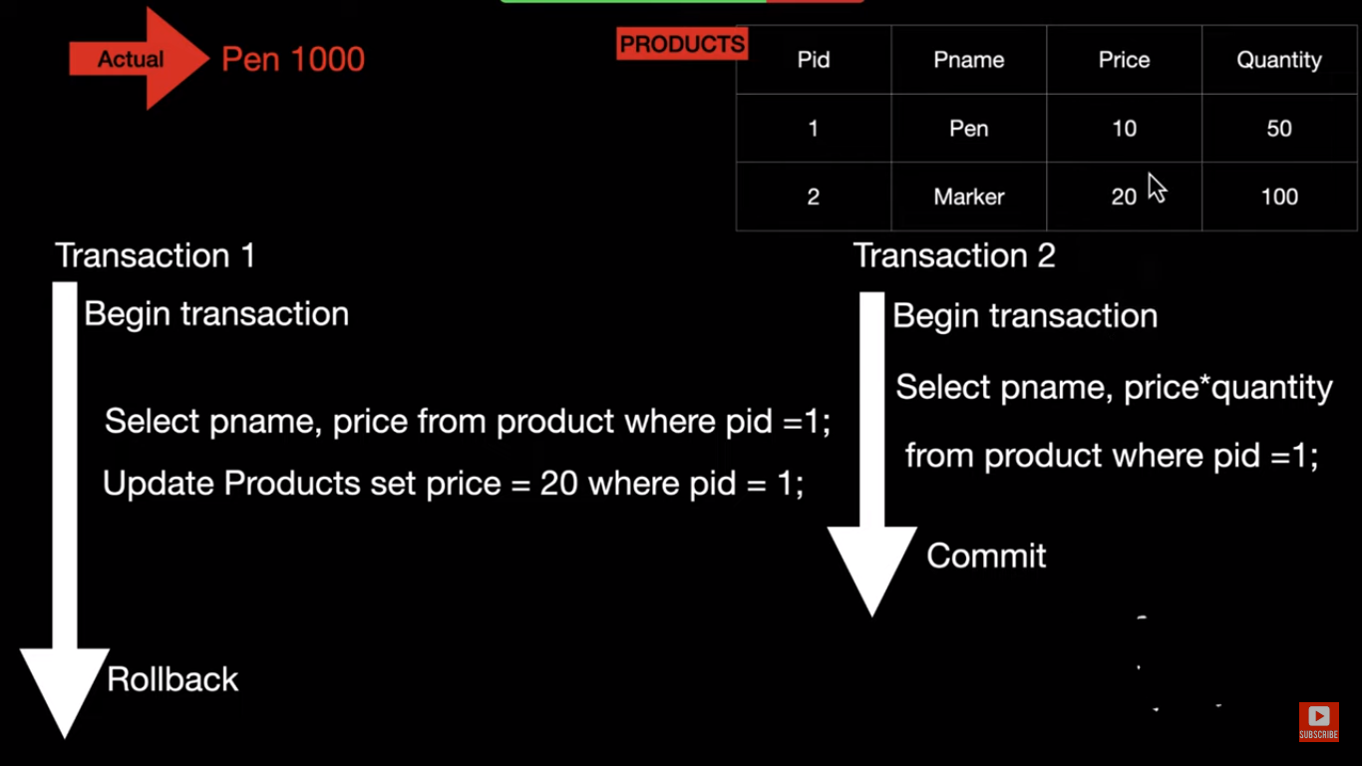

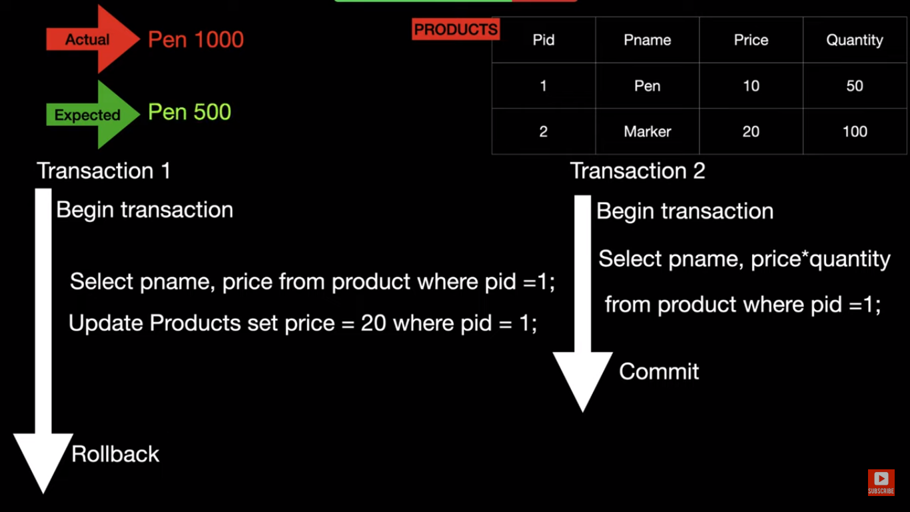

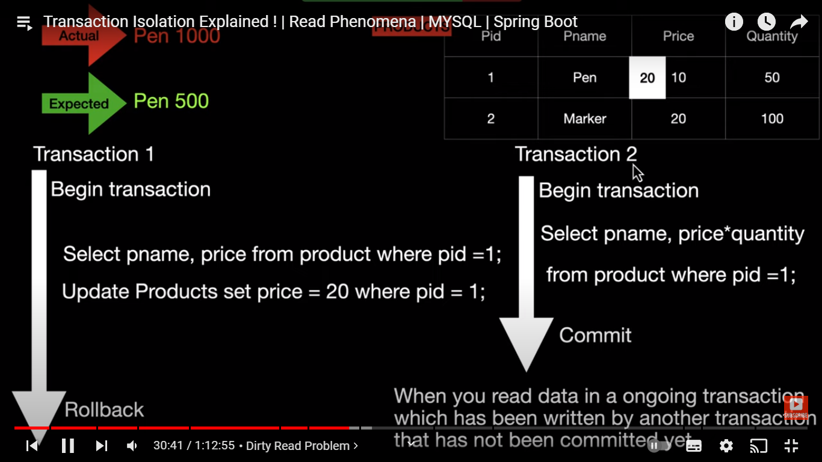

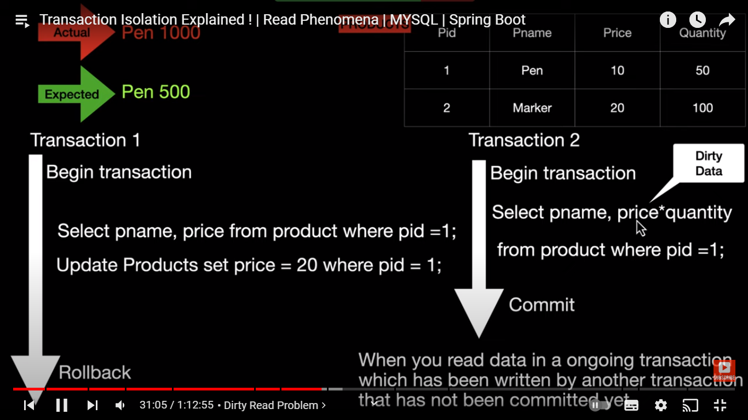

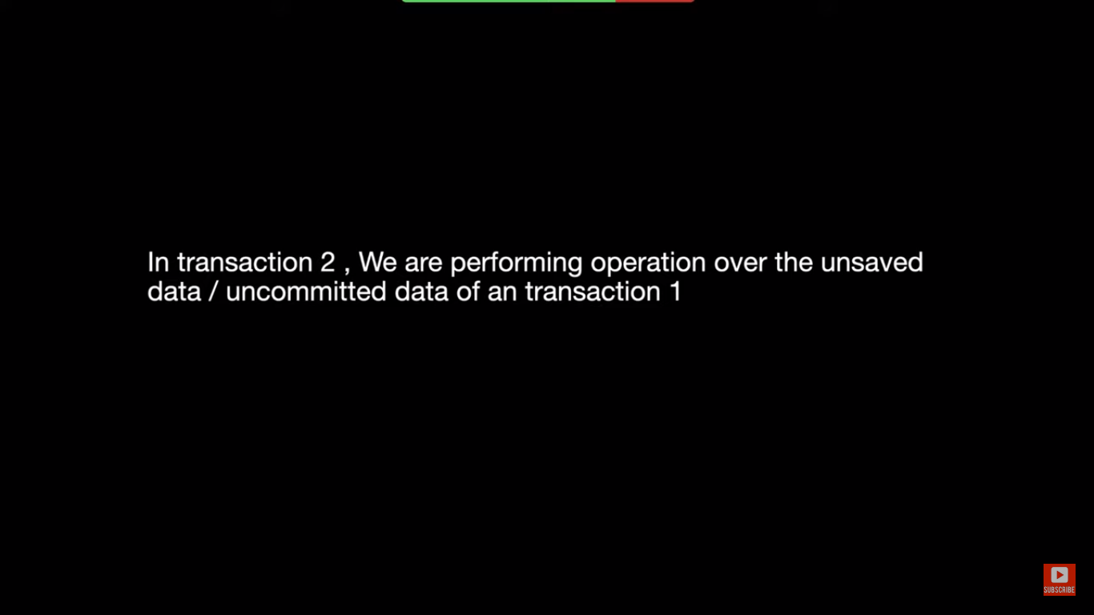

**What is Dirty Read ?**

**As** shown in above screenshot , there are 2 transactions running in parallel T1 & T2.

T1 & T2 started and T1 read the value of price where id is 1. Result is 10.

T1 updates the value of price to 20.

Meanwhile T2 is reading price* quantity value from table .and it will get updated value of 10 for price. So price * quantity = 1000.

But something went wrong in T1 and it got roll-backed. So price is now 5 again.

T2 has already read the value 10 which is now 5. So T2 read dirty data.

So we are performing operation in T2 over uncommitted data.

This is called as Dirty Read.

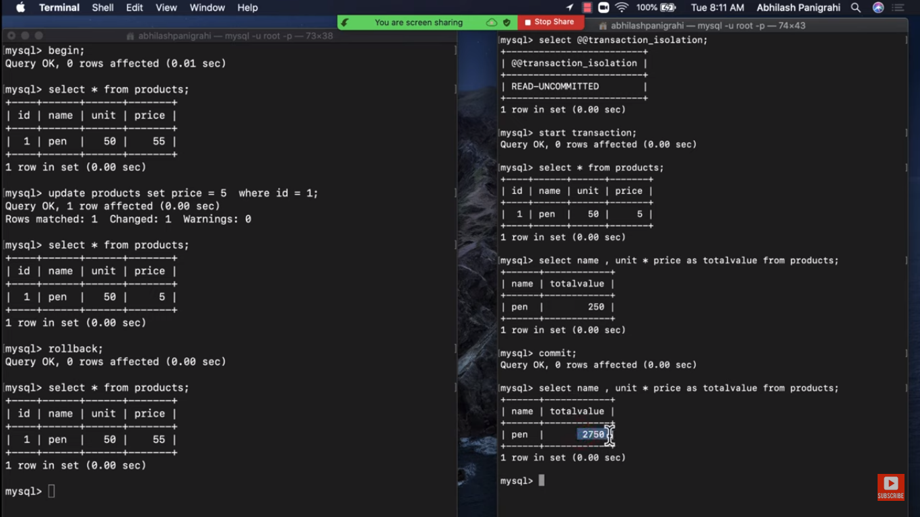

**READ_UNCOMMITTED** -> when the isolation level is Read uncommitted then problem of dirty read can come as explained above. Transaction T2 is reading the uncommitted value by transaction T1.

So suppose T1 will rollback then whatever value T2 has read it is not right. Its dirty value.

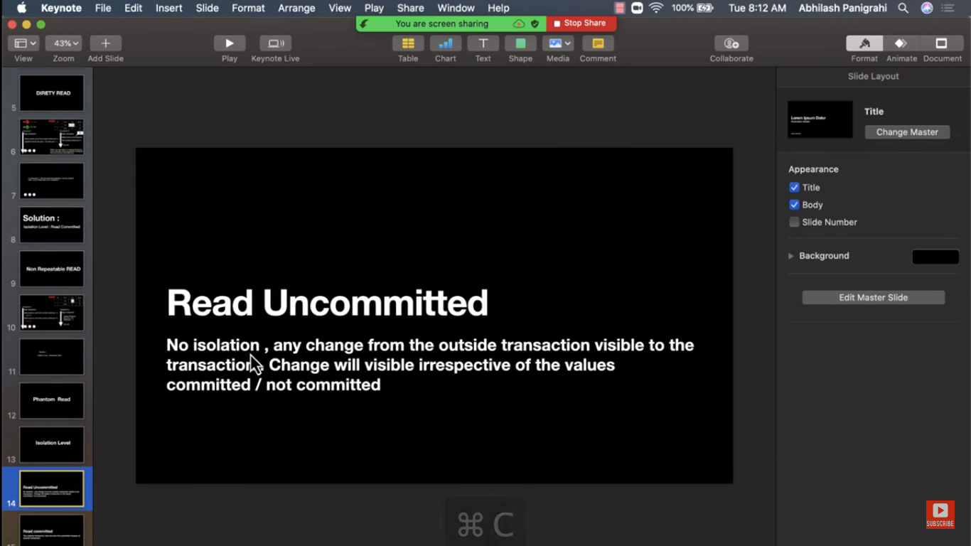

**READ COMMITTED** : When T1 and t2 are started .T2 has updated the value in ongoing transaction. then that value has read by T1 .

This means read the committed values of other transaction.

But problem here is non repeatable read shown in below slides.

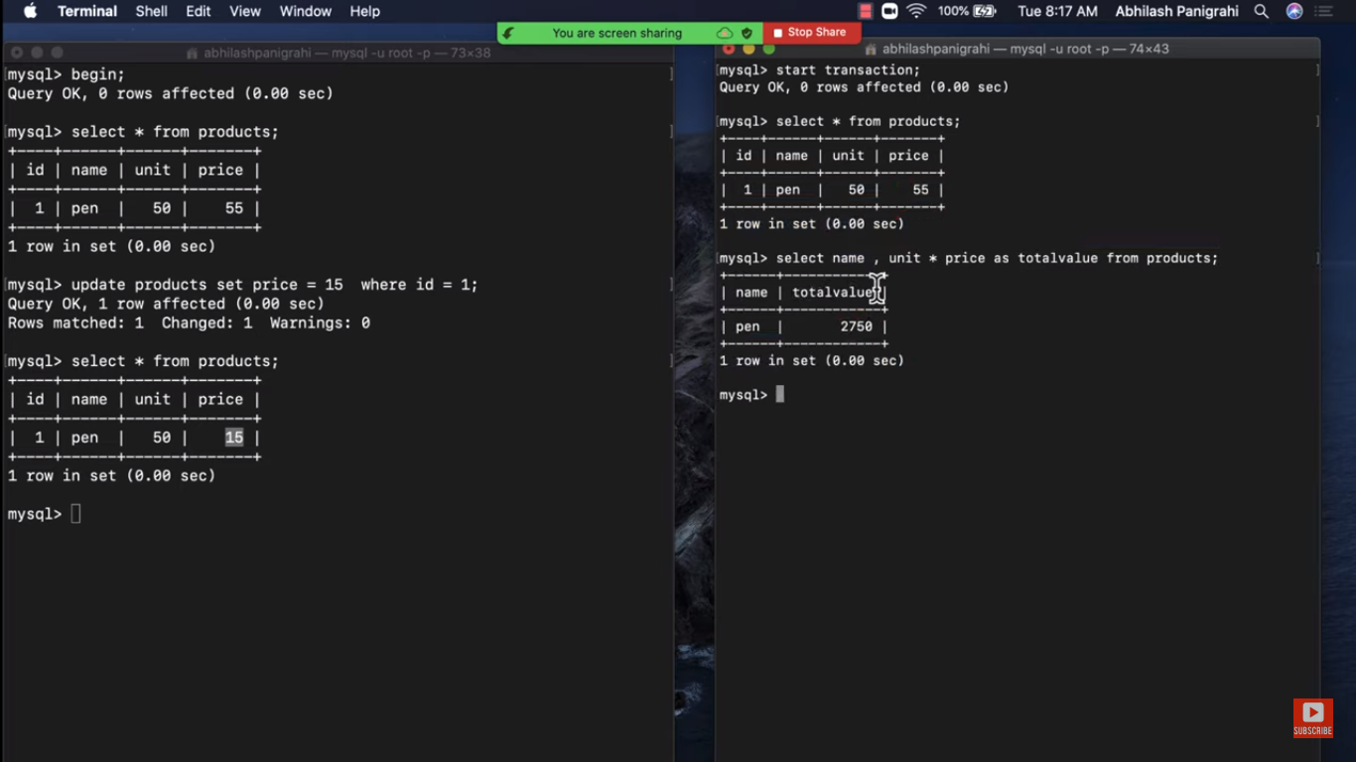

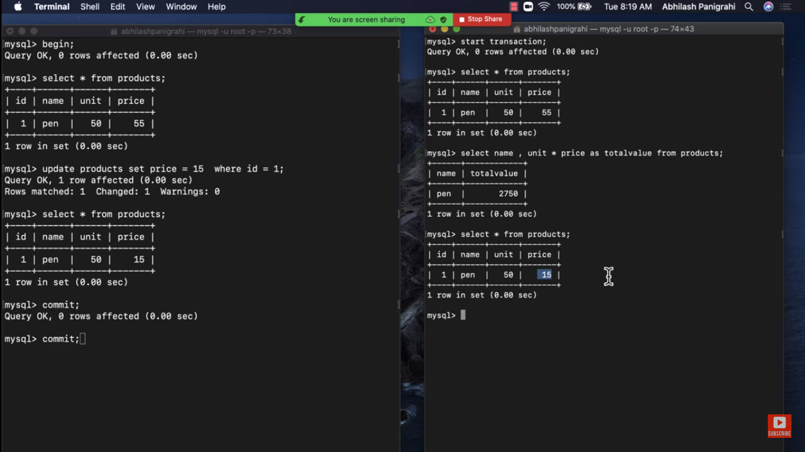

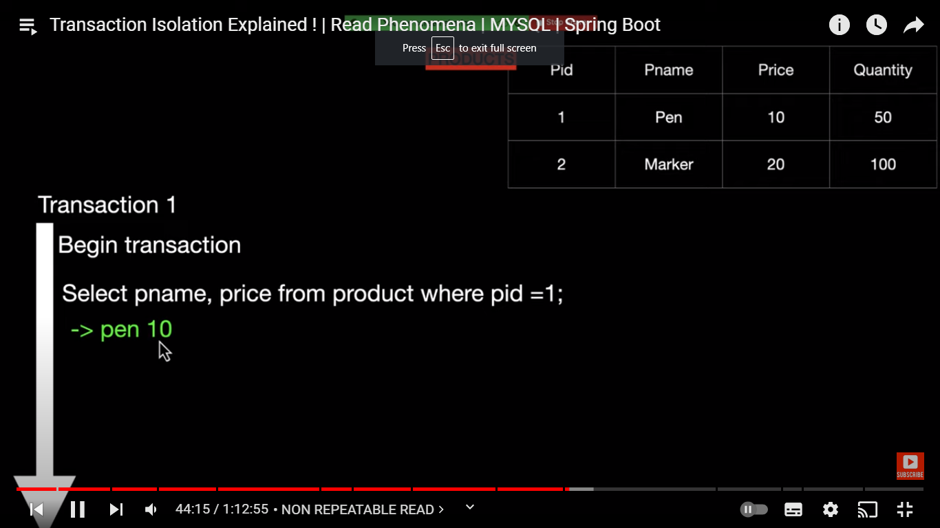

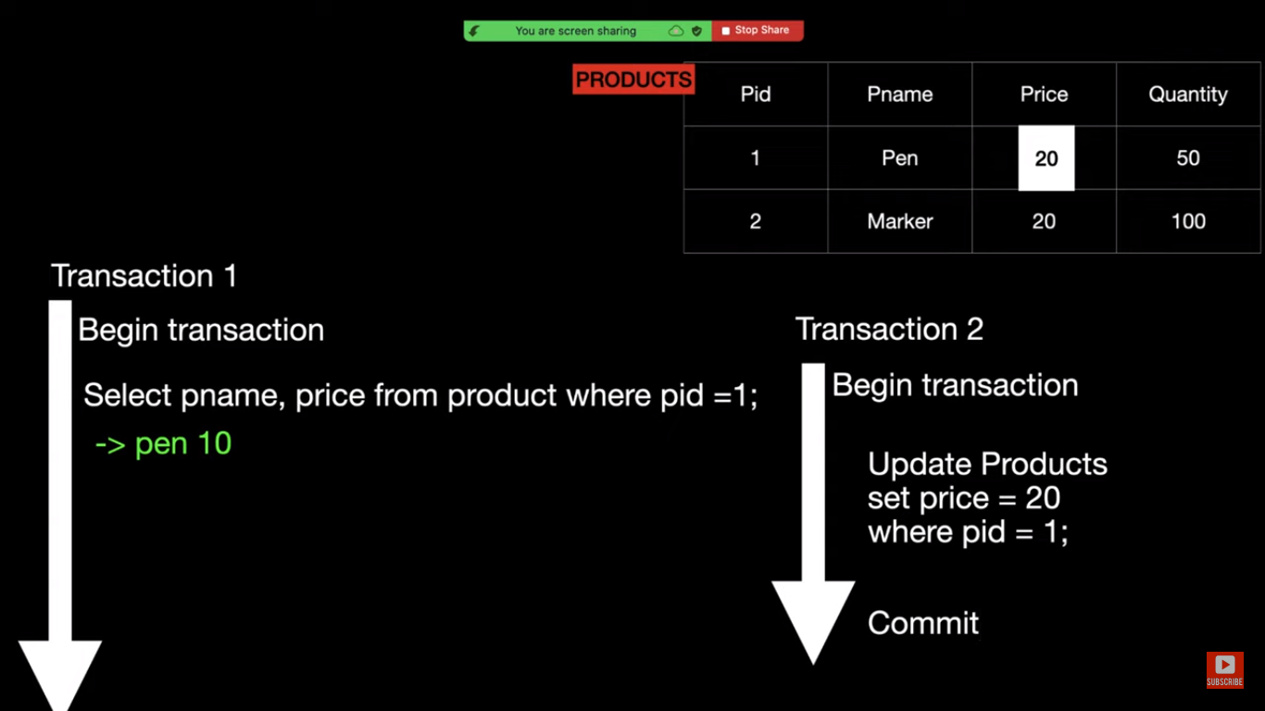

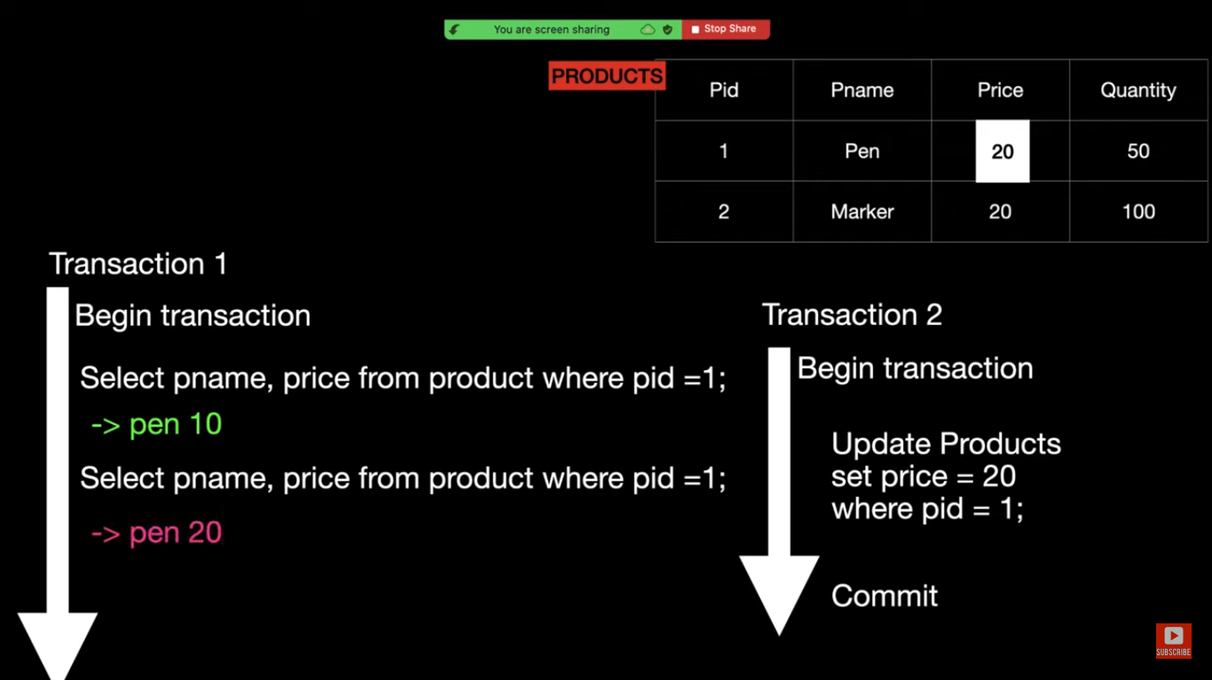

Here in transaction T1 and T2 are started.T1 reads the value of price as 10 .

After that t2 updates the value of price to 20.

T1 again executes select query and read value 20 .because isolation level is **read committed**.

So in same transaction T1 .we are getting different values of price at different time .

This is **non repeatable read**.

To solve this problem you have to change the isolation level to **repeatable read.(**discussed at the start of document**).** So it means in transaction if we execute the query to fetch some data then we should get consistent result throughout the transaction irrespective of other transaction has updated and committed same data.

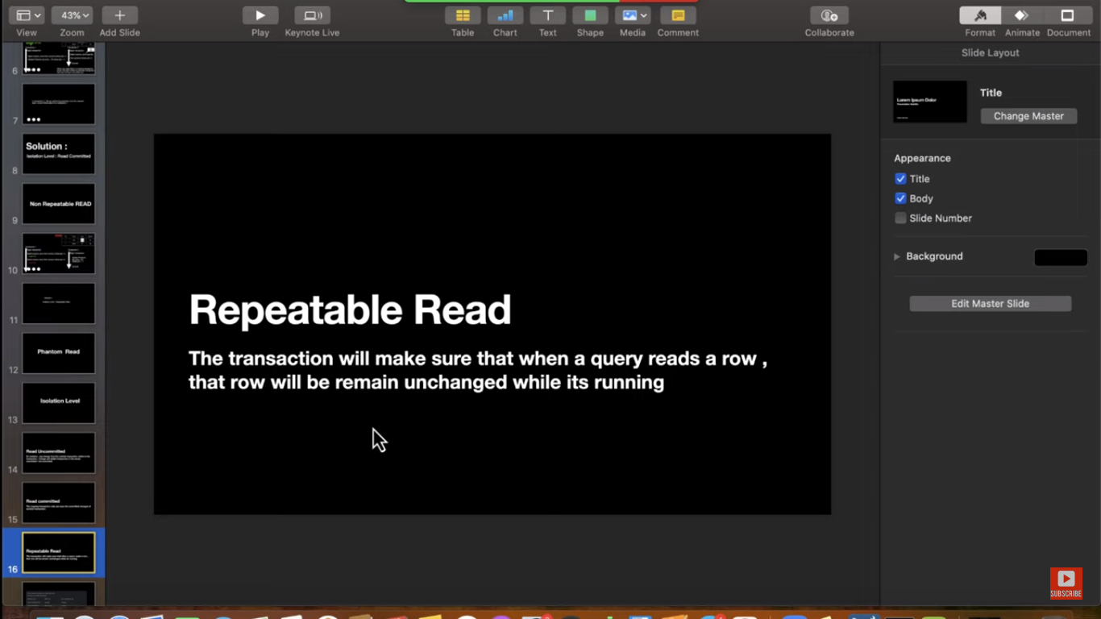

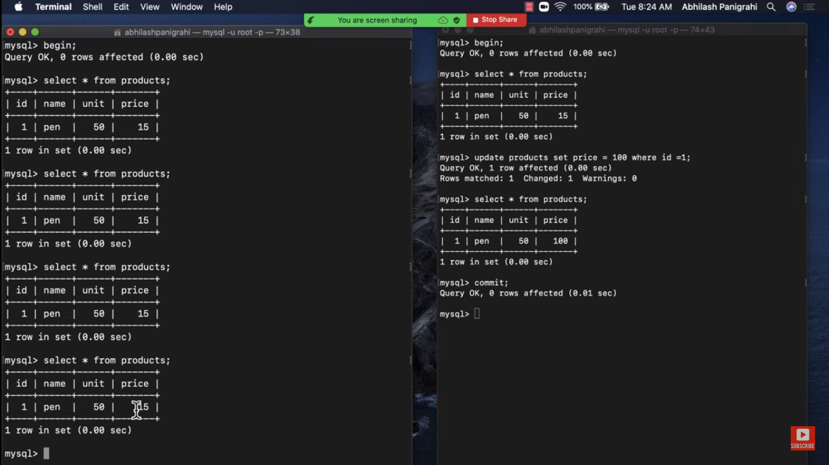

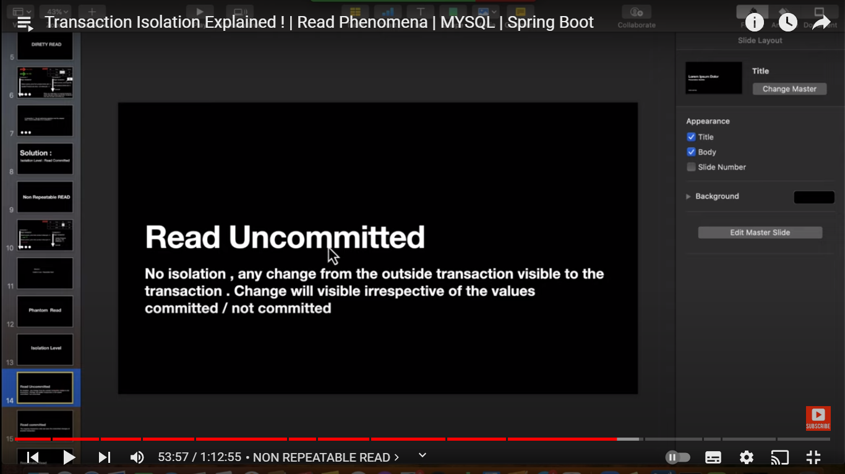

Problem of Dirty read and non repeatable read for Read Uncommitted level

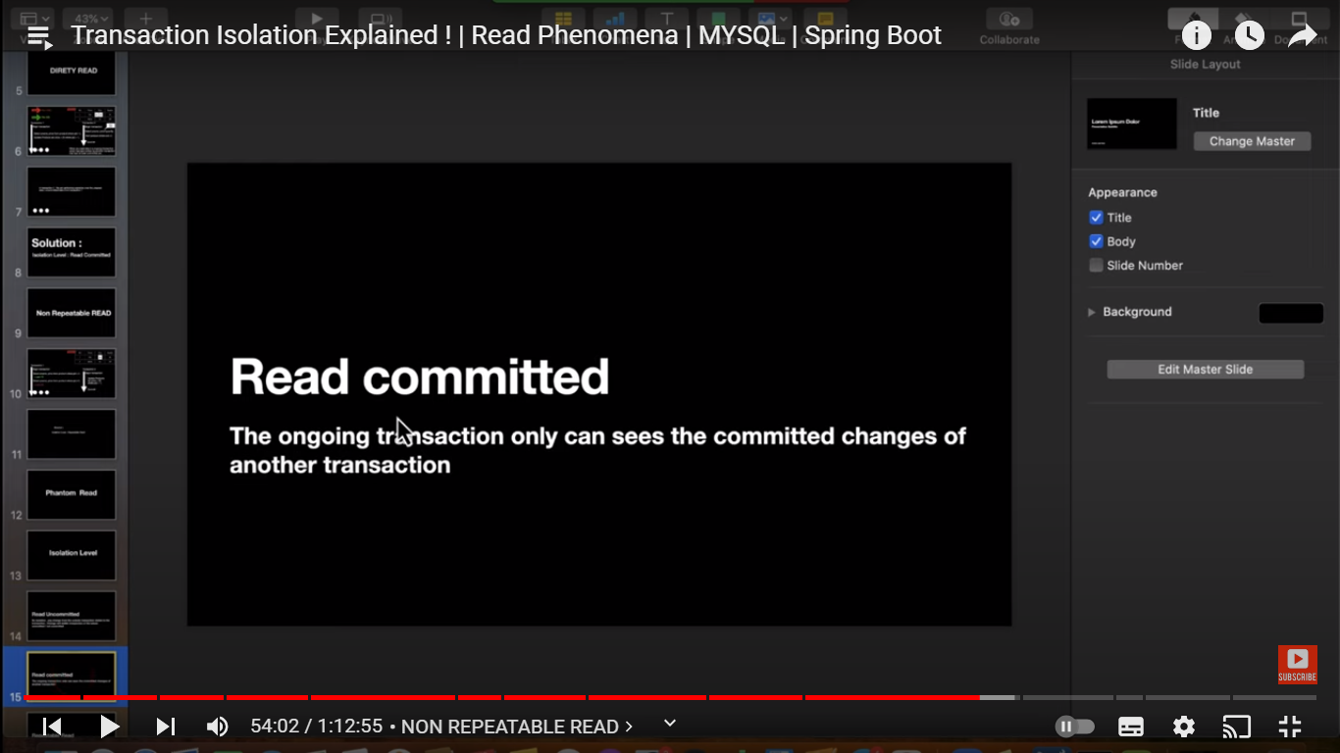

In Read Committed , Dirty read problem will go away but non repeatable read is still there.

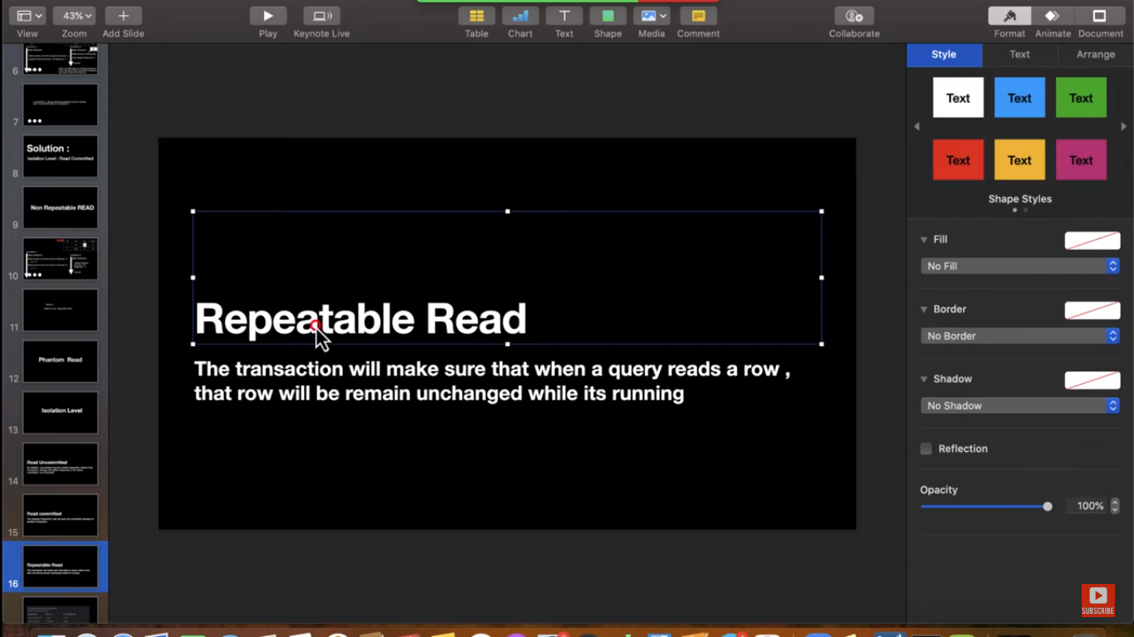

In Repeatable Read level , No Dirty read & no non repeatable read problem.

